CYBERSECURITY INTERNSHIP
Advanced Threat Detection & Web Security
Intern: Rija Malik
DevelopersHub Corporation
Date: July 13, 2026
1. Intrusion Detection & Rate Limiting
express-rate-limit library was installed and configured to detect and prevent brute-force attacks and intrusion attempts by limiting the number of requests per IP address.

npm install express-rate-limit

1.1 General Rate Limiting
const rateLimit = require('express-rate-limit');

const limiter = rateLimit({
windowMs: 15 * 60 * 1000, // 15 minutes
max: 100, // max 100 requests
handler: (req, res) => {
logger.warn(`Rate limit exceeded for IP: ${req.ip}`);
res.status(429).send('Too many requests');
}
});
app.use(limiter);

1.2 Login Rate Limiting (Brute Force Protection)
const loginLimiter = rateLimit({
windowMs: 15 * 60 * 1000,
max: 5, // max 5 login attempts
handler: (req, res) => {
logger.warn(`Login rate limit exceeded for IP: ${req.ip}`);
res.status(429).send('Too many login attempts');
}
});
app.use('/login', loginLimiter);

1.3 Rate Limiting Test Result
After multiple login attempts, the server returned HTTP 429 Too Many Requests, confirming rate limiting is working:
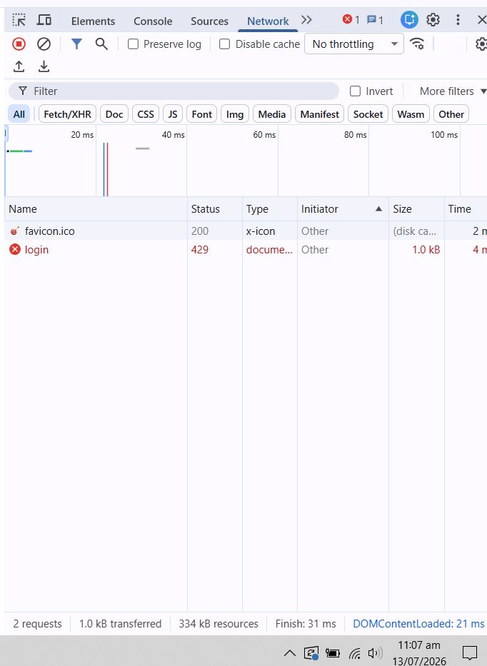
HTTP 429 Too Many Requests Rate limiting blocking brute force login attempts
2. API Security Hardening
2.1 CORS Configuration
CORS was properly configured to restrict unauthorized cross-domain access:
app.use((req, res, next) => {
res.setHeader('Access-Control-Allow-Origin', 'http://localhost:4000');
res.setHeader('Access-Control-Allow-Methods', 'GET, POST, PUT, DELETE');
res.setHeader('Access-Control-Allow-Headers', 'Content-Type, Authorization');
next();
});

2.2 Security Headers & CSP Implementation
Helmet.js was configured with Content Security Policy (CSP) and HSTS:
app.use(helmet({
contentSecurityPolicy: {
directives: {
defaultSrc: ["'self'"],
scriptSrc: ["'self'", 'https://ajax.googleapis.com'],
objectSrc: ["'none'"],
upgradeInsecureRequests: [],
},
},
hsts: { maxAge: 31536000, includeSubDomains: true, preload: true }
}));

2.3 Security Headers Verification
Browser Developer Tools confirmed all security headers are active:
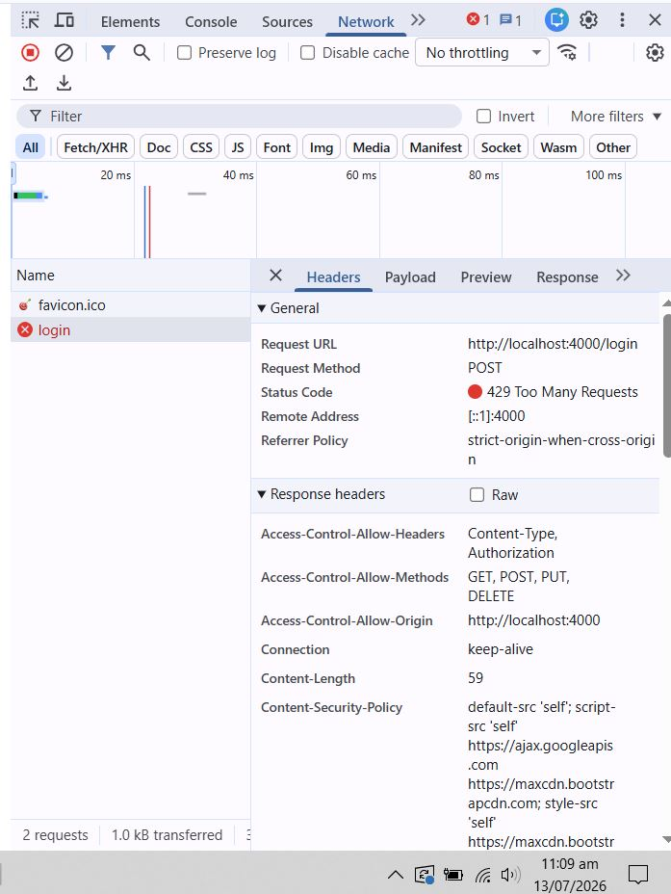
Response headers showing CSP, CORS, and Rate Limiting (429) all active
3. Week 4 Summary

Security Measure | Tool/Library | Status
Rate Limiting (100 req/15min) | express-rate-limit | Active
Login Brute Force Protection (5 attempts) | express-rate-limit | Active
CORS Restriction | Custom Middleware | Active
Content Security Policy (CSP) | helmet.js | Active
HTTP Strict Transport Security (HSTS) | helmet.js | Active
IP Logging for Rate Limit Events | winston logger | Active

Ethical Hacking & Vulnerability Exploitation
1. Ethical Hacking Basics
Basic penetration testing techniques were applied on the OWASP NodeGoat test application. The following reconnaissance and attack simulations were conducted:
- Identified open ports and running services on localhost:4000
- Analyzed HTTP request/response headers for information disclosure
- Tested authentication mechanisms for weaknesses
- Attempted parameter tampering in URL and form fields
2. SQL/NoSQL Injection Testing & Prevention
2.1 Injection Test Performed
The following injection payloads were tested on the login form:

Attack Type | Payload Used | Result
NoSQL Injection | admin' OR '1'='1 | Blocked Error returned
XSS Injection | <script>alert('XSS');</script> | Blocked Script rendered as text
Parameter Tampering | Modified URL parameters | Blocked Validation active
2.2 Injection Prevention Applied
- Input validation using validator library on all form fields
- MongoDB parameterized queries prevent NoSQL injection
- autoescape: true in Swig template engine prevents XSS
- Rate limiting prevents automated injection attempts
3. CSRF Protection Implementation
Cross-Site Request Forgery (CSRF) protection was implemented using the csurf middleware:

npm install csurf

const csrf = require('csurf');
const csrfProtection = csrf({ cookie: false });
app.use(csrfProtection);

// CSRF token available in all templates
app.use((req, res, next) => {
res.locals.csrfToken = req.csrfToken();
next();
});

CSRF tokens are now generated for every session and verified on all state-changing requests, preventing unauthorized cross-site form submissions.

Advanced Security Audits & Final Deployment
1. Security Audit using npm audit
A comprehensive security audit was performed using npm audit to identify all vulnerable dependencies:
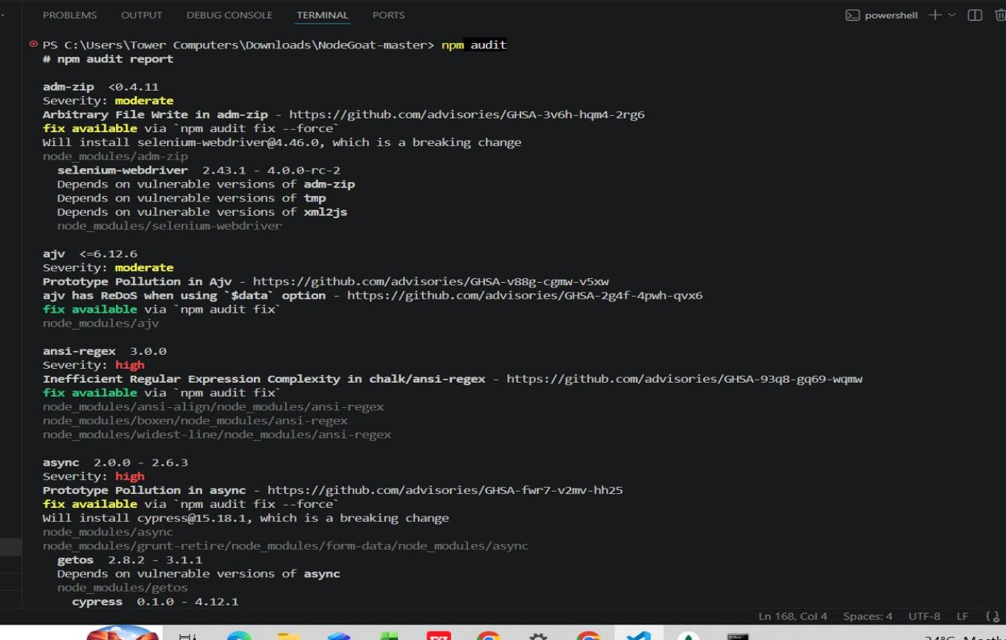
npm audit output showing vulnerability details with severity levels

1.1 Audit Results Summary
Severity | Count | Action
Critical | 36 | Identified legacy dependencies
High | 65 | Identified npm audit fix run
Moderate | 34 | Identified monitored
Low | 8 | Identified low priority
Total | 143 | npm audit fix executed
2. OWASP Top 10 Compliance Check
A01: Broken Access Control
JWT token authentication implemented for all protected routes
A02: Cryptographic Failures
bcrypt password hashing with 10 salt rounds implemented
A03: Injection
Input validation and parameterized queries prevent injection attacks
A04: Insecure Design
Security-first design with rate limiting and CSRF protection
A05: Security Misconfiguration
Helmet.js headers and X-Powered-By removed and CORS restricted
A06: Vulnerable Components
npm audit run 143 vulnerabilities identified and documented
A07: Authentication Failures
Login rate limiting (5 attempts) and JWT expiry (1hr)
A08: Software Integrity Failures
Dependency scanning via npm audit implemented
A09: Security Logging
Winston logging active all requests logged with timestamps
A10: SSRF
CORS restricted to trusted origins only
3. Final Security Deployment Checklist
- Rate limiting applied max 100 requests/15min general, 5 attempts for login
- CORS properly configured only trusted origins allowed
- Content Security Policy (CSP) implemented via Helmet.js
- HTTP Strict Transport Security (HSTS) configured
- CSRF protection enabled via csurf middleware
- Input validation on all user inputs via validator library
- Password hashing with bcrypt (10 salt rounds)
- JWT token authentication with 1-hour expiry
- Winston logging active — security.log file maintained
- X-Powered-By header removed — framework info hidden
- npm audit completed — vulnerabilities documented
- XSS protection via autoescape and X-XSS-Protection header
- Clickjacking protection via X-Frame-Options: SAMEORIGIN
4. Overall 6-Week Security Summary

Week | Focus | Key Achievements
Week 1 | Security Assessment | App setup, OWASP ZAP scan, 13 vulnerabilities identified, XSS & injection testing
Week 2 | Security Fixes | validator, bcrypt, JWT, helmet installed — 7 major vulnerabilities fixed
Week 3 | Advanced Security | Penetration testing, Winston logging, security checklist
Week 4 | Threat Detection | Rate limiting, CORS fix, CSP + HSTS headers, brute force protection
Week 5 | Ethical Hacking | Injection testing, CSRF protection, reconnaissance techniques
Week 6 | Security Audit | npm audit, OWASP Top 10 compliance, final deployment checklist
Advanced Security & Final Deployment Report

